|  |
| --- |
| Working Scientifically – Progression Map |

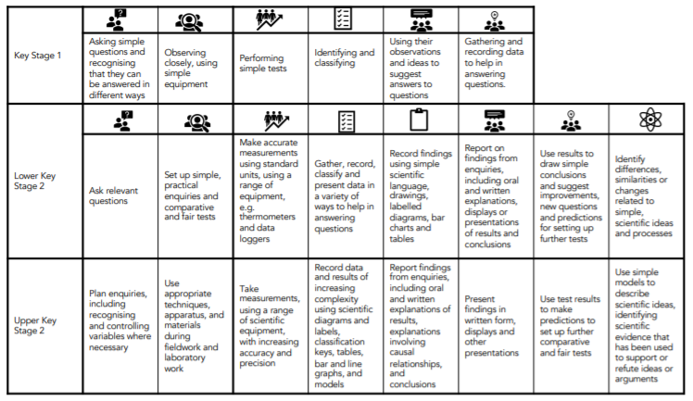

Science Long Term Map