PE at Ham Dingle
Our PE curriculum is delivered through Get Set 4 PE and aims to:  - Provide every child with a physical literacy journey  - Develop physical competence and confidence to excel  - Motivate pupils to succeed and excel in competitive sports.  - Lead healthy, active lifestyles.  - Build character and embed values such as fairness, respect as well as experience success and failure – learning to lose  Through Get Set 4 PE our PE lessons also include many key skills throughout each unit and these key skills are broken down in to:  - Physical  - Social  - Emotional  - Thinking | Big Ideas  We use the Get Set 4 PE curriculum to support the delivery of PE across the whole school. The pupils are physically active for sustained periods of time, at least twice weekly. The Big ideas are:  - Fundamental Movement skills  - Dance  - Fitness  - Gymnastics  - Athletics  - OAA  - Hockey  - Basketball  - Tag Rugby  - Golf  - Football  - Ball skills  - Games  - Rounders  - Volleyball  - Dodgeball  - Golf  - Netball  - Tennis  - Cricket  - Handball  - Badminton  - Invasion  - Striking and Fielding  - Net and Wall  - Target games  - Teambuilding  - Sending and receiving |  | Content and Sequencing  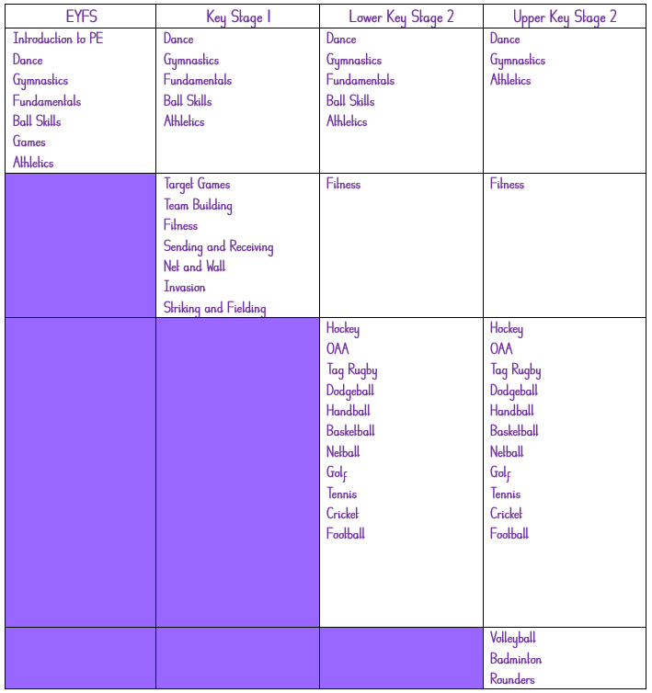  Get Set 4 PE provides a clear curriculum for each year group. These units are built on in consequent years where skills are further developed and applied to sports and games.
Deepening Concepts  To enable our pupils to think and behave like athletes, gymnasts, and sports people our deepening concepts in PE are:  - To develop an understanding of how to lead a healthy lifestyle  - To master practical skills  - To connect and apply skills  - To compete and perform |  | Links with other subjects  Children can link PE to mathematical skills in score keeping, recording distances, calculating improvements, finding averages (means), looking at shape, space and area on a pitch or court.  Children can link to English by using subject specific key vocabulary throughout their PE lessons and communicate these in sentences with a partner.  Children can link to Science by understanding the effect exercise has on the body and how the body reacts to different exercises, understanding which part of the body is used in jumping for height and exploring stance to increase power in their throw. |  | Lesson Design  Each lesson has:  - A clear structure of – example, explain, attempt, apply and challenge  - The teacher will begin with retrieval practice, where children will recall their learning from previous lesson or unit.  - The lesson will be introduced to the children and the teacher will lead a suitable warm up.  - Teacher will clearly model the skills that the children will be practising during the lesson.  - The children will then practise the skills independently or as part of a team.  - Children will then apply the skill as part of a game or activity.  - Children will evaluate and reflect on performance  - Cool down and engage in a plenary.
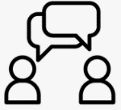  Vocabulary  Each learning module includes and teaches subject/unit specific vocabulary. This is linked to the skills that the children will be practising and applying in each unit and will be consistently referred to throughout the lesson and the unit. |  | Making Progress  Children make progress when there is a change in long term memory and when content is taught in small, manageable steps. This will reduce cognitive load. Units are sequenced, so prior knowledge, skills and concepts are built upon from previous year groups and units lead to improved skills and increased knowledge.  Individual progress is assessed through observations and recorded using assessment trackers. |  | Retrieval Practice  Retrieval practice is used as a learning tool, not just an assessment tool. It allows children to transfer their ideas from their working memory into the long-term memory. Retrieval encourages children to memorise knowledge and skills. In PE, this is often skills based and children are then encouraged to implement the skills in a variety of sports activities.  Each lesson begins with a recap of the last lesson and the skills/knowledge acquired.

